Project design phase - Il customer journey

|  |  |
| --- | --- |
| Date | 16 October 2022 |
| Team ID | PNT2022TMlD44607 |
| Project Name | GLOBAL SALES DATA ANALYSIS |
| Maximum Marks | 4 Marks |

customer journey

Business Business Analysis

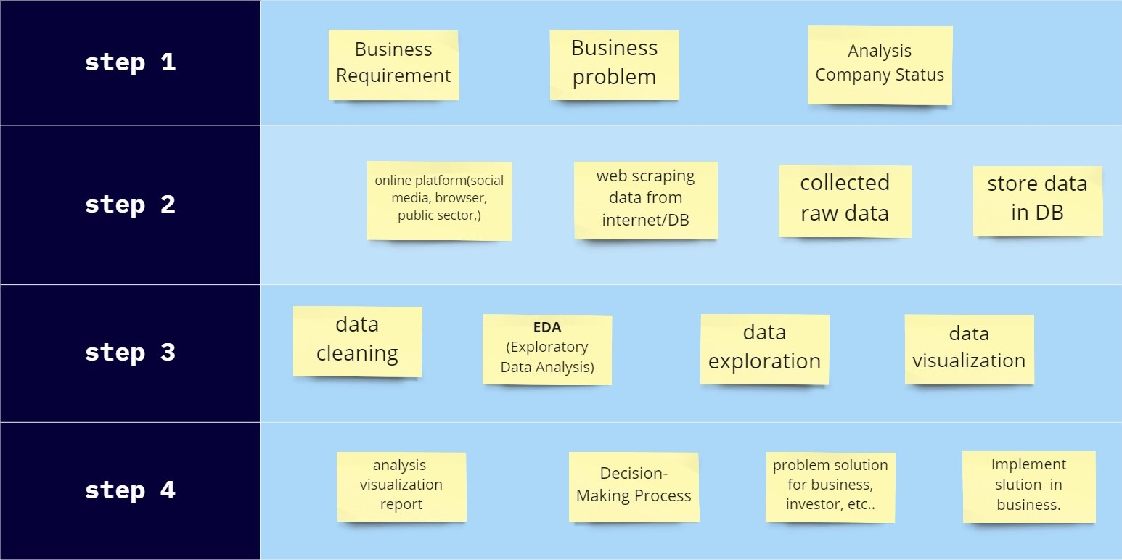

miro

Requirement problem Company Status

online platform(social web scraping collected store data media, browser, data from public sector,) internet/DB raw data in DB

data EDA data data

cleaning Data (ExploratoryAnalysis) exploration visualization